Jasper Middle School
(706) 253-1760
8th Grade Physical Science
2017-2018 Syllabus
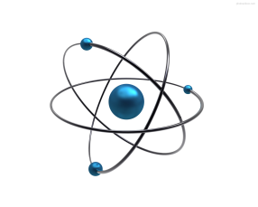

Teachers: Shelly Vincent (x 406) shellyvincent@pickenscountyschools.org
Anne Harwell (x302) anneharwell@pickenscountyschools.org

Text Book:
Physical Science by McDougal-Littell

Course Description:
The eighth grade science program is a basic introduction to physical science. A major goal of the program is to develop critical thinking skills that will enable students to become better problem-solvers and intelligent decision-makers. Students will be involved in learning activities that include lab safety techniques, hands-on labs, vocabulary development, research, current events, and the use of technology in science.

Class Format:
Each class period will begin with a daily warm up to review and reinforce skills previously learned. The class will then consist of a variety of teaching strategies that are designed to give students optimal opportunities to gain important knowledge about the subject being learned. Unless a student is absent or is significantly behind in work, minimal homework will be assigned with the exception of completion of daily assignments, home projects, and studying for tests.

Make-up Policy:
JMS’ make-up policy will be followed. It is the responsibility of the student to ask the teacher for make-up work.

Units of Study:

- Lab Safety, Scientific Method, Measurement
- Matter and Energy
- Chemical Interactions
- Motion and Forces
- Waves, Sound and Light
- Electricity and Magnetism

*For more in-depth information about 8th grade Physical Science state requirements, please visit the following link: http://www.georgiastandards.org.

Grading Scale:

Summative/Tests and Projects . . . . . . . . . . . . . . . . . . . . . . .40%
Formative/Labs, Classwork, Homework, and Quizzes . . … .60%

